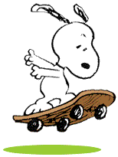
走囉…出國去…
拖著你的行李，帶著愉快的心情…
Take it easy!

你一定得知道…
- 提早2小時到機場辦理登機手續。
- 帶著你的護照(Passport)和機票(Ticket/Boarding pass) ，先到機場找到要搭乘航空公司的登機櫃檯。
- 把你的護照(Passport)和機票(Ticket) 交給櫃檯人員，辦理登機手續及劃位(Check-in)。
- 若有托運行李，要辦理相關手續(小心!!超重可要付額外的費用喔!)
- 要出境囉!! 記得將護照及機票隨手拿著。
- 辦理登機手續後，主要通關程序有：
辦理登機手續→海關→安檢→逛逛免稅商店→候機登機
- 通過安檢，通常你的隨身行李要放在盒子裡，用輸送帶並藉由X光機來檢查是否有危險物品。
- 在候機室等候廣播登機。【一般來說，飛機起飛前30分鐘會開始登機】
- 進入機艙時別忘了給服務人員你的登機證 (Boarding pass)。
- 找到號碼入座。
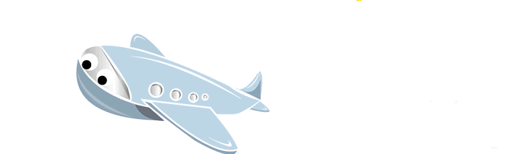
飛機起飛囉!!

別忘了…要繫上安全帶！
還有很重要的是…航機內禁止使用行動電話及電子遊樂器等電子裝備，
所以請關閉電源並將電子用品暫時關機。

Are you ready?! 準備好了嗎？
GO…
走…我們一起出國去…

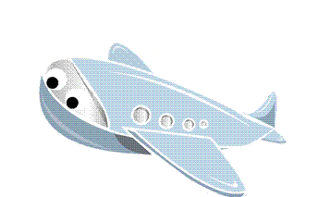
Check-in (到機場報到)
Unit
1


Check in (辦理登機手續和劃位)
實 用 句
報 到
服務員：Good morning/afternoon/evening. (早安/午安/晚安)
Your ticket and passport, please. (請給我看你的機票和護照。)
旅 客：Here you are. (在這兒。)
服務員：Thank you. (謝謝。)
Would you put your baggage here? (請把你的行李放這裡。)
I’ll check it through. (我要登記。)
旅 客：Sure. (好的。)
服務員：There will be a 20-minute delay. So your flight will be boarding in about an hour.
(飛機誤點20分鐘，所以你的班機會在一小時後登機。)
◆ 找櫃台時會問的話
Where is Eva Airways check-in counter?
長榮航空公司的登機手續櫃台在哪？
Excuse me, is this the line for flight EA123 to Japan?
請問這裡是在排往日本的 EA123班機嗎？
Is this the economy-class check-in counter?
這裡是經濟艙的登機手續櫃台嗎？
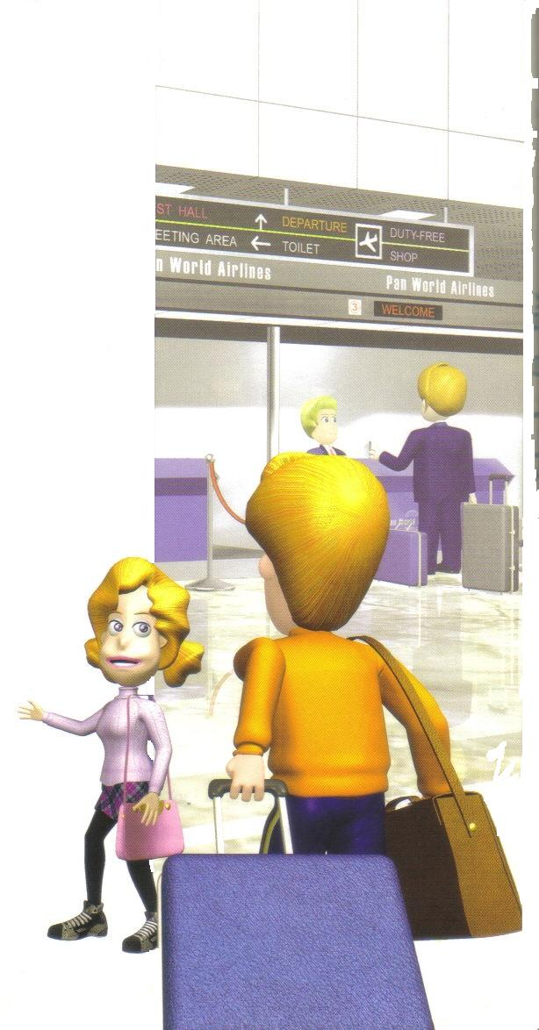

◆ 櫃檯人員會問的話
ticket?
May I have your passport?
visa?
可以看一下你的機票/護照/簽證嗎？

◆ 跟櫃台人員說你要的位置
I’d like an aisle seat. 我想要靠走道的位置。
I’d like a window seat. 我想要靠窗的位置。
Can I have a seat next to the exit? I have long legs.
我可以坐靠逃生門的位置嗎？我的腳很長。
I’m flying with my friend. Can we get two seats together?
我和朋友一起搭飛機，可以給我們兩個在一起的座位嗎？


Check in bags (托運行李)
實 用 句
服務員：Please set your baggage upright here. (請把你的行李擺直放在這裡。)
I’ll have to weigh it. (我要秤多重。)
(過磅後….)
The baggage is overweight, sir. (先生，你的行李超重。)
You have to pay $65.00. (你要付65元美金。 )
旅 客：Can I charge it on credit cards? (我可以用信用卡嗎？)
服務員：Yes. We accept major credit cards. (可以，我們收主要的信用卡。)

◆ 行李過秤時櫃檯人員會說的話
How many luggages will you be checking in? 你要拖運幾件行李？
Please put your luggage on the scale. 請把行李放在磅秤上。
Please fill out this name tag and tie it to the handle of your suitcase.
請塡好這個名條然後綁在你的手提箱手把上。
Your suitcase is overweight. 你的行李箱超重。
You’ll have to pay an extra charge. 你得付額外的費用。

◆ 行李過秤時旅客會說的話
I have one check-in bag and one carry-on bag.
我有一件托運行李和一個隨身行李。
Can I carry this bag on the plane? 我可以帶這個包包上飛機嗎？
Is my luggage over the limit? 我的行李超過限制嗎？

認識各種不同的行李
carry-on bag 隨身行李 |  | check-in bag 托運行李
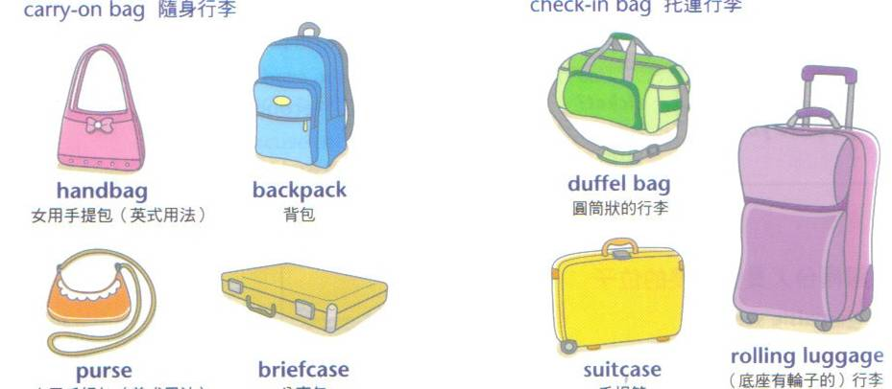 |  |  | rolling luggage  (底座有輪子的)行李
handbag女用手提包(英式) | backpack 背包 | duffel bag  圓筒狀行李
purse 女用手提包(美式) | briefcase 公事包 | suitcase 手提箱


Security and immigrations (安檢和出入境)
實 用 句
出 境
通 過 安 全 門
服務員：Put all your carry-on bags on the belt, sir. (把你隨身行李放在輸送帶上。)
旅 客：The digital camera, too? (數位相機也要嗎？)
服務員：Yes, please. It won’t hurt it. (是的，不會損壞它的。)
Now, step through here. (現在，從這裡走過去。)

安全門的警鈴響了
服務員：Are you wearing any metal? (你有戴任何的金屬品嗎？)
旅 客：I don’t know. (我不知道。)
Maybe it’s the belt. (可能是這條皮帶。)
服務員：Take it off and put it in the box here. (把它脫下來，放到這個盒子裡。)
And walk through again….. (再重走一次。)
That’s fine. Here’s your belt. (沒問題了，你的皮帶拿回去。)
旅 客：Thank you. (謝謝你。)


大補帖 - 入 境 他 國
入境時，海關人員可能會問你的一些問題：
1. Q: What’s the purpose of your visit? 你來訪的目的？
A: I come here to study. / to visit my relatives. / for sightseeing. / for business.
我來這裡唸書 / 來拜訪親戚 / 來觀光 / 來出差 的。
I am just passing through. 我只是過境。

2. Q: How long will you be staying? 你打算停留多久？
A: I am going to stay for one week. / five days. 我將在這裡待一個禮拜 / 5天。

3. Q: Where will you be staying? 你打算住在哪裡？
A: I am staying with my relative/friends. / at a hotel. 我將住在親戚(朋友)那裡/住飯店。

4. Q: Did you bring any fresh fruits or meat products with you?
有攜帶新鮮水果或肉製品嗎？
A: No, I didn’t. 不，沒有。

5. Q: Do you have anything to declare? 有東西要申報嗎？
A: No, this digital camera is for my personal use. 沒有，這台數位像機是我自己的。
No, these souvenirs are for my friends. 沒有，這些紀念品是要送朋友的。

Boarding and Taking off (登機和起飛)
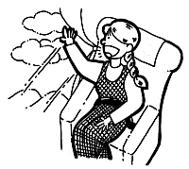
實 用 句
道 別 上 飛 機
Announcement：”Flight 801 to ________ now boarding at Gate 3.”
(廣播：往____801次班機現在在3號門登機)
旅 客：That’s our flight. Let’s go. (那是我們的班機。走吧！)

《小常識》
置放隨身行李：隨身行李較輕者請置於頭頂行李架上，較重者則置於座位底下。
飛機起飛前請記得把桌子收起，繫好安全帶，並將椅背扳直。

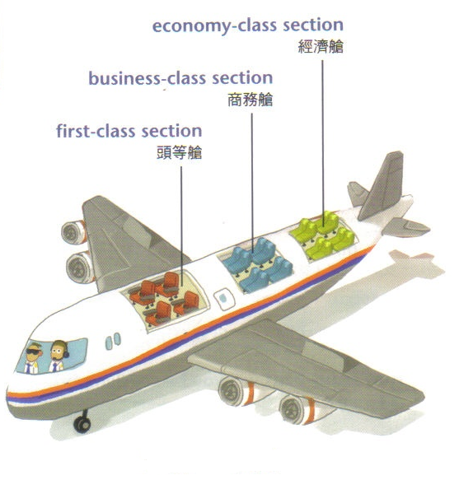
economy-class section 經濟艙

business-class section 商務艙

first-class section 頭等艙

飛機座艙概略圖

Buying Duty-Free (購買免稅商品)
Unit
2
實 用 句

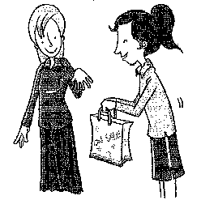
在 機 場
(clerk:店員 passenger:乘客)
Clerk：How may I help you?
Passenger：Yes, I would like to buy 購買商品名稱 .
Clerk：Sure. It’s NT $2000 in total. Cash or card?
Passenger：Card, please.
Clerk：OK. Wait a minute. (after a while…) Please sign here.
Passenger：Here you go.
Clerk：Here are your receipt and credit card voucher.
Passenger：Thank you
Clerk：Have a nice trip, sir.

◆ 免稅商店店員會說的話
May I see your boarding pass, please? 可以給我看你的登機證嗎？謝謝。
The exchange rates for foreign currencies are listed here. 外幣匯率表在這裡。
Would you like to pay it by credit card ?
All major credit cards are accepted. 我們接受任何的信用卡。
I will bring it to you right away. 我馬上拿給你。
Have a nice trip, sir. 祝您一路順風。

◆ 購買免稅商品會問的話
How many bottles of 酒 名 can I buy? 我可以買幾瓶__________嗎?
How many cartons of cigarettes can I buy? 我可以買幾條香菸嗎?
Do you accept credit card/ Visa card / Master card ? 你們收信用卡嗎?
What is the exchange rate if I use American dollars? 如果我用美金，匯率多少?

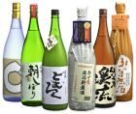
生 活 情 境 對 話
(C = clerk店員 P = passenger乘客 )
【Scenario 1 場景一---Buying cigarette and liquor 買菸酒 】
C: How may I help you? (有我能為您服務的嗎？)
P: Yes, I would like to buy some wine as a gift for a friend. (是的。我想買一些酒送我朋友。)
C: Which type of wine would you like? (你想要買哪一種酒？)
P: Hmmm...I really have no ideas since I barely drink wine. Which ones would you recommend? (嗯…我很少喝酒沒有概念。 你推薦哪種酒呢？)
C: Let's see... I would suggest you buy either a bottle of white wine in this brand or a bottle of red wine in that brand because these two are the most popular ones in our shop.
(我看看…我會建議買這牌子的白酒或是那牌子的紅酒，因為這兩種酒是我們店裡賣最好的。)
P: I see, mmm, I guess I will take one of each. Thanks for your suggestions.
(我知道了。 我這兩種都各買一瓶。 謝謝你的意見。)
C: Not at all, may I please see your boarding pass and your passport.
(不客氣。可以看一下你的登機證和護照嗎？)
P: Here are my boarding pass and passport. (在這裡。)
C: The total comes to $120 dollars. Would you like to pay it by credit card?

(總共是120元。 您要刷卡嗎？)
P: Yes, please. Here you go. (After a while) (是的。信用卡給你。)
C: Please sign your name here. (請在這裡簽名。)
C: Thank you very much and have a nice day. (謝謝並祝您玩得愉快。)

【Scenario 2場景二--- buying cosmetics 買化妝品】
C: How are you doing today? How can I help you? (您好。有我能為您效勞的嗎？)
P: Hi, I’m looking to buy a set of cosmetics for my sister but I don't know which brand I
should get. (你好。我想買一組化妝品送我姐姐，但是我不知道我該買哪一個牌子。)
C: How old is your sister, if you don't mind me asking. (不介意的話，請問你姐姐幾歲呢？)
P: She just turned 24 last week. (她上禮拜剛滿24歲。)
C: I’d recommend this brand for your sister because it is popular among ladies in their 20's.
(我會推薦這組，因為這組產品在20幾歲的女士中很受歡迎。)
P: I know this brand, I think I have seen her using it before. This would work.
(我知道這個牌子，我好像有看她用過。 可以帶這組喔。)
C: Ok, now we'll need to know if your sister has an oily, sensitive or dry type of skin.
(好的，那麼請問她是油性、敏感性還是乾性肌膚？)
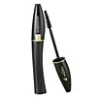
P: I think her skin type is oily and sensitive. (她應該是敏感油性膚質吧！)
C: Then I would recommend this particular line of products.
(那麼我會建議你買這系列的產品。)
P: Thanks for your suggestion, I will take those. (謝謝。我買這一整組。)
Also I’ll have this mascara altogether. How much are they?
(還有這一條睫毛膏一起買。總共多少呢？)
C：Let me see…..it comes to US$110. Cash or card? (總共110元。付現還是刷卡？)
P：By credit card. Here it is! (刷卡。給你。)
C: Thank you…wait a moment. Please sign here. (謝謝。請稍等一下。麻煩在這簽名。)

【Scenario 3場景三--- buying clothes and accessories in boutique 買服裝配飾】
C: Can I help you with anything? (我能幫您什麼忙嗎？)
P1: We’ll just have a look…. (我們看一下…)
P2: Excuse me, I’d like to buy this pair of earrings, but can I have a discount?
(你好，我想買這對耳環，有沒有打折？)
C: Sorry, no bargaining here. (抱歉。恕不折扣。)
P1: Do you have any necklace? (那你們有項鍊嗎？)
C: Yes, this is the latest style and one of the top brands in France.
(有的。這條是最新款而且在法國是很知名的品牌。)
P1: It looks gorgeous. How much is it? (看起來很華麗。 多少錢？)

C: $500. (伍佰元。)
P1 : Great! I’ll take it. (好。我買這個。)
C: Cash or card? (付現還是刷卡？)
P1: Cash. (付現。)
C: Thank you. (謝謝。)

Unit
3
In the plane (在飛機上)


In-flight Meals & asking for service (機上用餐及空服員的服務)
長途飛行時，通常會在機上用餐，而空服員會推著琳瑯滿目的餐車問你要什樣的飲料或點心，你知道如何說嗎？
實 用 句
向空服員要東西
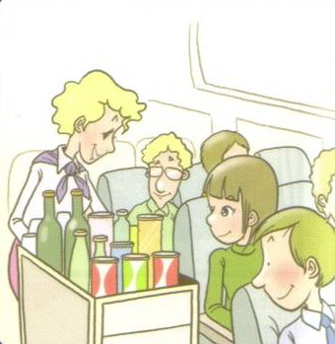
旅客：Could you bring me a blanket, please? (可否請你拿條毯子給我？)
空姐：Sure, I’ll get one for you later. (好的，我待會兒拿一條給你。)

空服員提供飲料
空姐：Anything to drink? (你要喝什麼？)
旅客：Yes, give me white wine. (好的，請給我白酒。)
空姐：Do you want ice with it? (你要加冰嗎？)
旅客：No, thank you. (不用，謝謝。)

提供餐飲
空姐：Excuse me, do you want beef or chicken meal for lunch? (對不起，你要牛肉餐還是雞肉餐？)
旅客：Chicken, please. (我要雞肉餐。)
空姐：What do you want to drink? (你要喝什麼？)
旅客：Orange juice, please. (柳橙汁。)

Is there anything I can get for you? 你想要什麼呢？ Anything to drink? 要喝點什麼嗎？
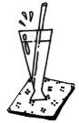  I’d like +  我想要… | a Sprite. 一杯雪碧。
 | a Coke. 一杯可樂。
 | a beer. 一杯啤酒。
 | some wine. 一杯酒。
 | some nuts. 一些堅果。
 | another glass of wine. 再一杯酒。

飛行中若有任何需要，我們都可以向空服人員尋求
May I have +  麻煩給我… | a pillow / blanket? 一個枕頭 / 毯子？
May I have +  麻煩給我… | a headset? 一副耳機？
May I have +  麻煩給我… | some newspaper / magazines? 一些報紙 / 雜誌？
May I have +  麻煩給我… | a pack of cards? 一副撲克牌？
May I have +  麻煩給我… | a pair of slippers? 一雙拖鞋？
In-flight Problems 飛行中可能遇到的問題
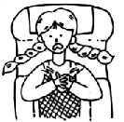
◆ 飛行中…如果身體不舒服的話，可以說…
Excuse me, I’m not feeling well. 不好意思，我覺得不舒服。
Do you have any aspirin? I have a headache/backache.
你有阿斯匹林嗎？ 我頭痛/背痛。
My stomach is upset. I think I am going to vomit.
我的胃不舒服。 我想我快吐了。
My ears are all blocked up. 我耳鳴。

◆ 搭飛機有時會遇到亂流或氣候不佳的情況，這時機長一定會廣播請乘客回座位做好，
並繫上安全帶，我們來聽聽看廣播是如何說的。
This is your captain speaking. We ask all passengers return to their seats at this time and fasten their seat belts. We’re experiencing a little turbulence, but it’s not serious and we should be getting through it soon.
我是機長，請所有的乘客回到座位並繫上安全帶。我們正遇上亂流，還好不嚴重，
我們應可迅速通過。


Buying Duty-Free on the Plane (機上購買免稅商品)
出國旅行，還有一件讓人高興的事就是可以在機場或飛機上購買免稅商品，為了防止民眾大量購買，有些東西是限量商品，購買的時候不要忘記問清楚喔！
實 用 句

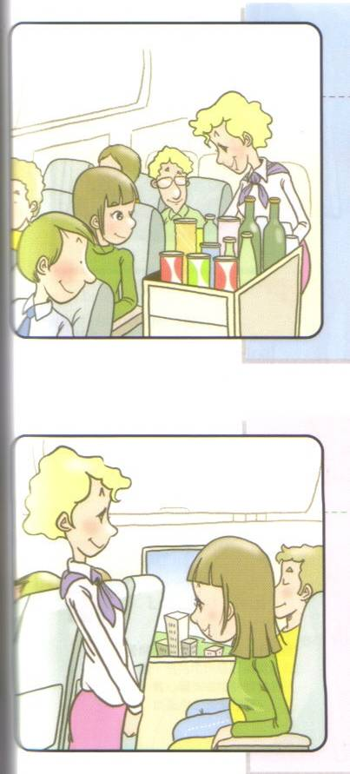
◆ 買免稅商品會問的話
Excuse me, when can we buy duty-free items?
不好意思，我們什麼時候可以買免稅商品？
How do I buy duty-free items? 我要怎麼買免稅商品？
I want to buy this perfume. 我想買這個香水。
I ordered a bottle of perfume, but it hasn’t arrived yet.
我訂了一瓶香水，但到現在都還沒送到。
◆ 空服人員會說的話
Just fill out this form, and we’ll deliver the items to you.
只要塡好這個單子，我們就會送此商品給您。
I’m sorry. We don’t have any left in stock. 對不起，我們沒有庫存了。
We will bring it to you right away. 我們馬上拿給您。
Currency Exchange (兌換外幣)
Unit
4

換錢時，一定會說到數字和匯率，你知道這些要怎麼說嗎?

☆ 數字的說法 |  |  | ☆ 比率的說法
一百 | one hundred |  | 1:10 | one to ten
一千 | one thousand |  | 1:5.75 | one to five-point-seven-five
一萬 | the thousand |  | 1:33.68 | one to thirty-three-point-six-eight
十萬 | One hundred thousand

☆ 若 以 美 元 舉 例
＄576 | 唸作 five hundred and seventy-six dollars
＄576.76 | 唸作 five hundred (and) seventy-six dollars and seventy-six dollars
＄4,576 | 唸作 four thousand five hundred and seventy-six dollars
＄44,576 | 唸作 forty-four thousand five hundred and seventy-six dollars
＄444,576 | 唸作 four hundred (and) forty-four thousand, five hundred (and) seventy-six dollars

☆ 兌 換 外 幣 實 用 句
I would like to change some money. 我想要錢。
What is the exchange rate? 匯率是多少?
What denominations do the bills come in? 鈔票有哪幾種面額?
I’d like to change this in to US dollars, please. 我想把這個兌換成美金。
Do you accept traveler’s checks? 你們收旅行支票嗎?
I’d like to buy a thousand U.S. dollars worth of traveler’s checks. 我想買一千美元的旅行支票。

References：1. Live ABC互動英語會話百科-觀光與旅遊
2. 長榮航空-出入境準則
3. 網路資料

Worksheet 學 習 單
Name:
哎呀！怎麼辦…如果發生以下狀況，你要如何…???
狀況一：好高興喔！到機場了…可是，如果你找不到你要登記的櫃檯，你該如何問….?
狀況二： 行李好多喔! 要確認行李有沒有超重，你該如何問…？
狀況三：如果你想要求一個靠窗的位子，你該如何跟櫃檯人員說？
狀況四：在飛機上，如果你口渴了，你該如何說…？
狀況五：在飛機上，如果你口渴了，你該如何說…？
狀況六：在飛機上，如果你想購買飛機上的東西，你該如何說？
狀況七：在飛機上，如果你真的很不舒服，你該如何說？
狀況八：下飛機後，要入境囉…海關人員會問你 What’s the purpose of your visit?
你該如何回答？
狀況九：如果你要去換錢，想把台幣5,000換成美金，你該如何說…？
狀況十：如果你要去換錢，想把台幣10,000換成美金，你該如何說…？

I think I’m….. | Excellent |  | Good |  | So so |  | Poor

